Shipping:

Inbound/outbound Rates:
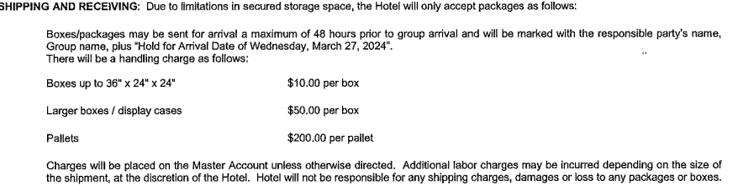

Inbound Instructions: -
Upon arrival, give one of our staff members the name of your package and they will deliver your package to you.
Label each box with the details specified below:
Attn: Data Connectors, Dawn Morrissey
Exhibiting Company and Onsite Contact
c/o Fedex Office/UPS/SHIPPING DOCKat VENUE
Address
Conference name
Box ___ of ___

Outbound Instructions:
Leave all intended packages for shipping, labeled and ready to go. Please make sure to call and schedule a pick-up to ensure you have your packages delivered to you.
Shipping Contact: Daisy Perez, daisy.perez@atriumhospitality.com, (919)459-1509

